EXECUTIVE SUMMARY REPORT: SUPERSTORE SALES DATASET
Overview
This report looks at the Superstore's sales and profitability using insights from the Power BI Executive Performance Dashboard. The aim is to understand how the business is performing, identify areas doing well, and highlight where improvements may be needed.
Although the company generates substantial sales, looking at revenue alone does not give a complete picture of its performance. It is also important to understand how much profit the business makes, which regions and products contribute most, and where there may be opportunities to improve profitability.
- Overall Sales and Profitability
Finding: The Superstore generated $2.30 million in total sales and $286,410 in total profit, with an overall profit margin of 12.47%. This shows that the business is making a profit, although there may be opportunities to improve the amount it earns from its sales.
Recommendation: Management should look beyond increasing sales and also focus on improving profit margins. This could involve reviewing heavily discounted products, identifying unnecessary costs, and paying closer attention to products that generate high sales but contribute relatively little profit.
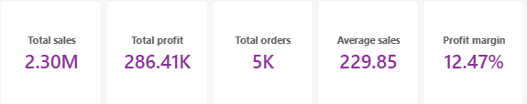

- Differences in Regional Performance
Finding: The West and East regions perform well in terms of sales and profitability. However, the Central region has a lower profit margin of approximately 8%, despite generating a reasonable amount of sales. This suggests that higher sales do not necessarily translate into higher profitability.
Recommendation: Management should investigate what is affecting profitability in the Central region. Reviewing discount levels, shipping costs, and the performance of individual products could help identify where profit is being lost and what changes may be needed.
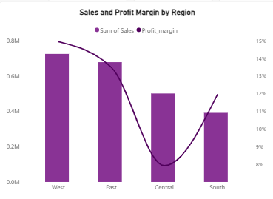
3. Customer Segments and Revenue Contribution
Finding: The Consumer segment contributes the largest share of sales, accounting for 50.56% of total revenue. The Corporate segment follows at 30.74%, while Home Office accounts for 18.69%. This shows that individual consumers are the company's main source of revenue.
Recommendation: The business should continue serving its Consumer customers while exploring ways to grow sales from Corporate and Home Office customers. Targeted promotions, product bundles, and business-focused offers could help attract more orders from these segments.
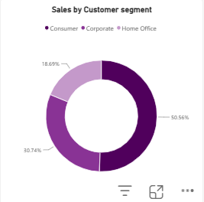

4. Sales Trends Throughout the Year
Finding:The monthly sales trend shows that sales are relatively low in January and February, increase in March, and rise again towards November and December. These changes suggest that demand varies throughout the year.
Recommendation: The Management should use these patterns to plan stock levels and marketing activities more effectively. Preparing for periods of higher demand could help the business avoid stock shortages and make the most of sales opportunities.
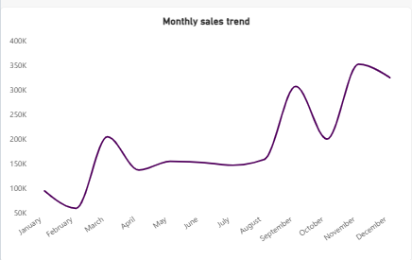
5. Products with High Profit Margins
Finding: Items such as the Ativa V4110MDD Micro-Cut Shredder and Zebra ZM400 Thermal Label Printer as products with relatively high profit margins, approaching 50%, despite contributing less to total profit than some higher-selling products. This suggests that certain specialised products may offer better returns relative to their sales.
Recommendation: Management should consider promoting these products to relevant customers in order to boost their overall profitability
